\*\*\*\*\*\*\*\*\*\*\*\*\*\*\*\*\*\*\*\*\*\*\*\*\*\*\*\* Top of Data \*\*\*\*\*

IDENTIFICATION DIVISION.

PROGRAM-ID. PROG14.

DATA DIVISION.

WORKING-STORAGE SECTION.

01 WS-INPUTS.

03 WS-A PIC 9(02).

03 WS-B PIC 9(02).

01 WS-OUTPUTS.

03 WS-C PIC 9(04) VALUE ZERO.

03 WS-D PIC 9(04) VALUE ZERO.

03 WS-E PIC 9(04) VALUE ZERO.

03 WS-F PIC 9(04) VALUE ZERO.

PROCEDURE DIVISION.

ACCEPT WS-INPUTS

PERFORM UNTIL WS-INPUTS = 'XXXX'

IF WS-A IS NUMERIC AND WS-B IS NUMERIC

PERFORM PARA1

ELSE

DISPLAY 'INPUTS ARE NON NUMERIC - NUMERIC CHECK '

END-IF

ACCEPT WS-INPUTS

END-PERFORM.

DISPLAY 'END OF DATA'

STOP RUN.

PARA1.

ADD WS-A WS-B GIVING WS-C

DISPLAY 'SUMC = ' , WS-C

SUBTRACT WS-A FROM WS-B GIVING WS-D

DISPLAY 'SUBC = ' , WS-D

MULTIPLY WS-A BY WS-B GIVING WS-E

DISPLAY 'PRODC = ' , WS-E

IF WS-B = ZERO

DISPLAY 'ZERO DIVIDE NOT POSSIBLE'

ELSE

DIVIDE WS-A BY WS-B GIVING WS-F

DISPLAY 'DIVC = ' , WS-F

END-IF.

\*\*\*\*\*\*\*\*\*\*\*\*\*\*\*\*\*\*\*\*\*\*\*\*\*\*\* Bottom of Data \*\*

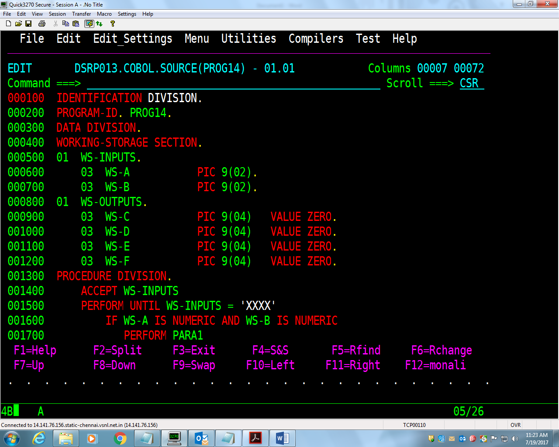 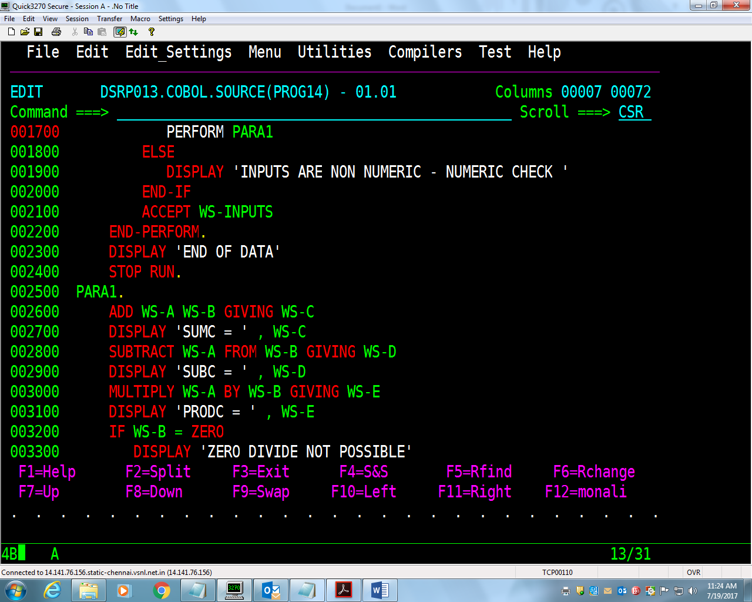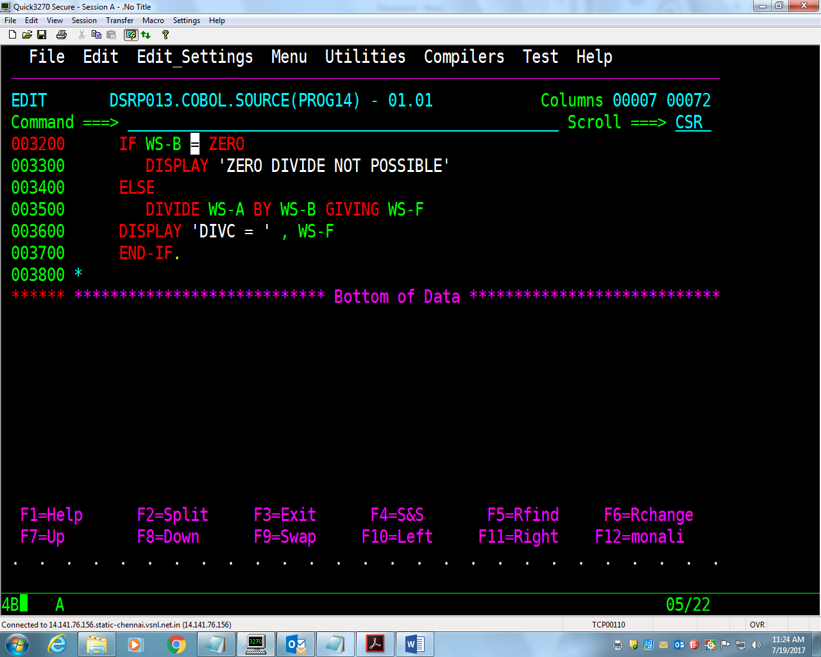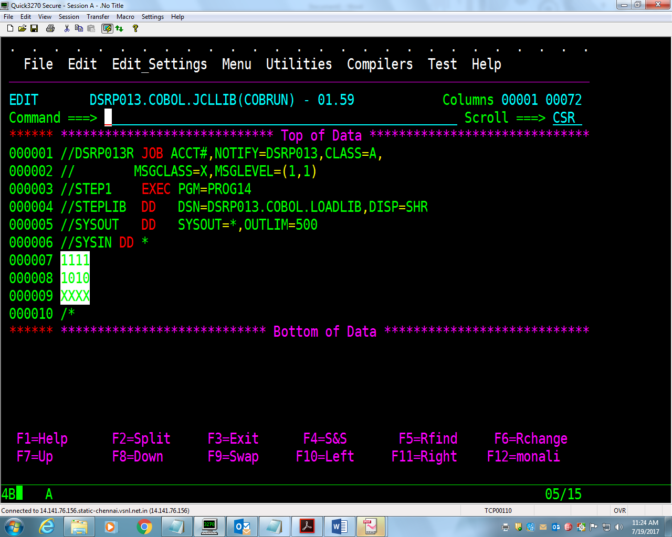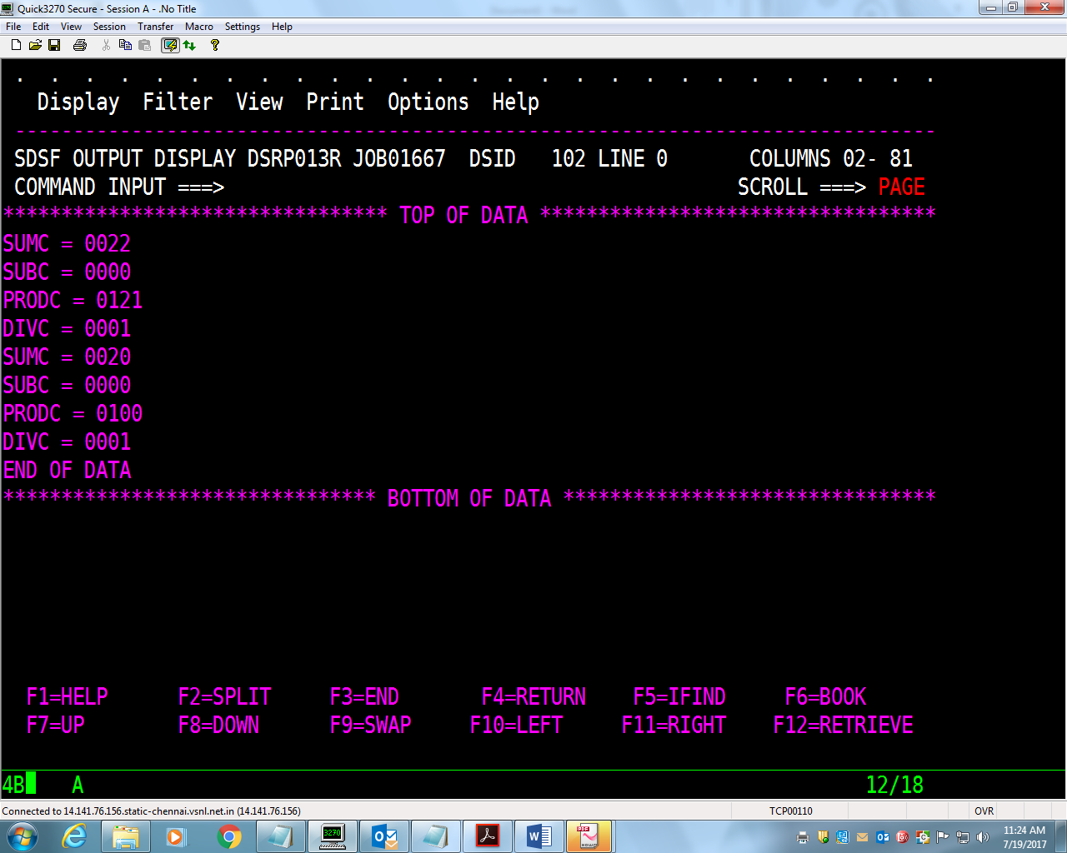

Zhzngggggggggggggggggggggggggggggggggggggggggggmkl

